# **Semester Project – Object Oriented Analysis and Design – Iteration 1**

Before getting started on Iteration 1, be sure to carefully review the Project Introduction document and get to know the JSON demos. The overall project is 40% of your semester grade and Iteration 1 is worth 20% of the project.

# Iteration 1 Reminder (from Intro)

**20% - Iteration 1** – You get started by creating a use case diagram showing the big use cases and actors involved in the project. Next, you perform class design for *domain objects* and design a state machine that handles the process of creating a complete trip. In addition to the polished use case diagram, class diagram, and state machine diagram you must provide, you also write a one-page document describing your designs to convince the CTO you are ready to go to the next iteration. To get full payment for this iteration, the CTO requires your work to demonstrate that you thoroughly understand the domain model and how to implement the domain model. The CTO is your executive sponsor at Premium and if your work isn’t great, he loses credibility at work.

# Iteration 1 Grading Rubric

1. **Use case domain diagram: 20%**  
   *Accurate depict the overall project domain including the various actors and large use cases. Proper use of stereotypes for includes and extends relationships should be included as appropriate*. *Your diagram will be graded for accuracy, completeness, and level of professionalism (so if it’s messy, expect that to count off).* *Carefully study the introduction document to perform this diagram properly*. *Also keep in mind this is a domain-level diagram, so avoid abstractions not related to the domain*.
2. **State machine diagram: 20%**  
   *Review state machine diagrams in your textbook (page 486). You also need to read the CTO’s notes in this document and the intro document related to states the Trip object will go through from creation to completion. Your diagram will be graded for accuracy, completeness, and level of professionalism (so if it’s messy, expect that to count off). Note that you do not have to design the state machine’s implementation (class diagram) in this iteration – just the state machine diagram.*
3. **Class diagram: 30%**  
   *Use good UML class diagram techniques to start to design how the domain diagram translates into a class diagram. You will be updating this diagram in Iteration 2, so I recommend using a diagramming tool like NClass (your choice – use whatever you like as long as you use the UML arrows, etc. we use in this in course). If you draw the diagram by hand, you will be drawing it by hand again in iteration 2 and that won’t be fun.  
     
   Carefully study the intro document and the details included in this* *document before creating your class diagram. Be sure to consider items that will be inherited, interfaces, composition or aggregation relationships, etc. You do not need to worry about patterns yet – just convert the domain diagram into a class diagram.  
     
   Your diagram will be graded for accuracy, completeness, and level of professionalism (so if it’s messy, expect that to count off). I suggest including comments to point out important facets of your work.*
4. **One-page writeup: 10%**  
   *Your one-page writeup (it can be longer, but please, keep it short) should have three parts – one for each diagram. Briefly tell me something significant about the diagrams. What is “significant”? I don’t know. You tell me what is important. Maybe that means “we need a lot more information here to do this properly and here’s why” or “this bit looks complex, but it’s quite simple and here’s why”. Anytime you make a claim, be sure to explain your claim.*   
     
   *To grade this section, I expect professional language,* ***zero*** *spelling and grammar issues, and a brief, informative summary of the work. The CTO at Premium is very busy and doesn’t want to read a bunch of dull, obvious stuff, such as what the definition of each diagram is… he already knows that. Tell him something significant. Point out risks and offer solutions. Be a great consultant so you look good and so does the CTO. That’s how you get more work and build a great reputation.*
5. **Submission files: 20%**  
   *You must submit 4 files zipped into a single file. The filename will be* ***YourName_Iteration1.zip****. If you are a team of 2, the filename will be* ***YourName1_YourName2_Iteration1.zip****. The four files include:*
   1. *Hi-rez copy of your domain diagram (PNG or JPG). I must be able to zoom in and read it comfortably. Name it*   
      *YourName_Iteration1_Domain.PNG (or YourName1 etc if team of 2).*
   2. *Hi-rez copy of your state diagram (PNG or JPG). I must be able to zoom in and read it comfortably. Name it*   
      *YourName_Iteration1_State.PNG (or YourName1 etc if team of 2).*
   3. *Hi-rez copy of your class diagram (PNG or JPG). I must be able to zoom in and read it comfortably. Name it*   
      *YourName_Iteration1_Class.PNG (or YourName1 etc if team of 2).*
   4. *Your one-page writeup as a Word DOC or PDF. Name it YourName_Iteration1_Writeup.DOC (or YourName1 etc if team of 2).  
        
      This should be the easiest bit of Iteration 1. Please make my life easier by doing this bit carefully. You will get 20% if it’s right, 10% if it’s a little bit off, and 0% if I must do a lot of work to piece your Iteration 1 artifacts together.  
        
      If you are a Team of 2, each of you should submit the* ***same*** *zip file. Note your team partner when submitting. This makes grading easier. You also will not get a grade until you meet with me during office hours to discuss Iteration 1, as noted. I require that teams balance the workload and that both members are experts in the material. Otherwise, one team member could get a lower grade than the other.*
6. TLDR  
   *Be neat, professional, and thorough. Know the domain very well. Ask questions if you need information. If you think there is a mistake somewhere, ask. Do not wait until the last minute to do this.*

# UML State Diagram

You remind Premium’s CTO you need more information about the states of a Trip because he requires a state machine in the final implementation. He draws a crude diagram, photographs it with his mobile, and texts it to you.

You note that the CTO writes like a small child and silently give thanks he drew that nice domain diagram for you on a computer (which you still had to QA for him and point out the errors, ugh). You *promise* yourself to ask a lot of questions about it because his handwriting is terrible (though he promises he drew it several times and this is the best version).

You also plan to review how to make great UML state diagrams. You remember seeing a lecture about them in a class you took once, but you never actually drew one before now.

Your primary goal is to draw something that graphically captures the states and transitions of the Trip building process, including resuming later and validating input so no step can be completed until the minimum required data is produced.

Your secondary goal is to draw something polished and professional, so the CTO can show his executive team and look smart by hiring you. You don’t want to embarrass your executive sponsor.

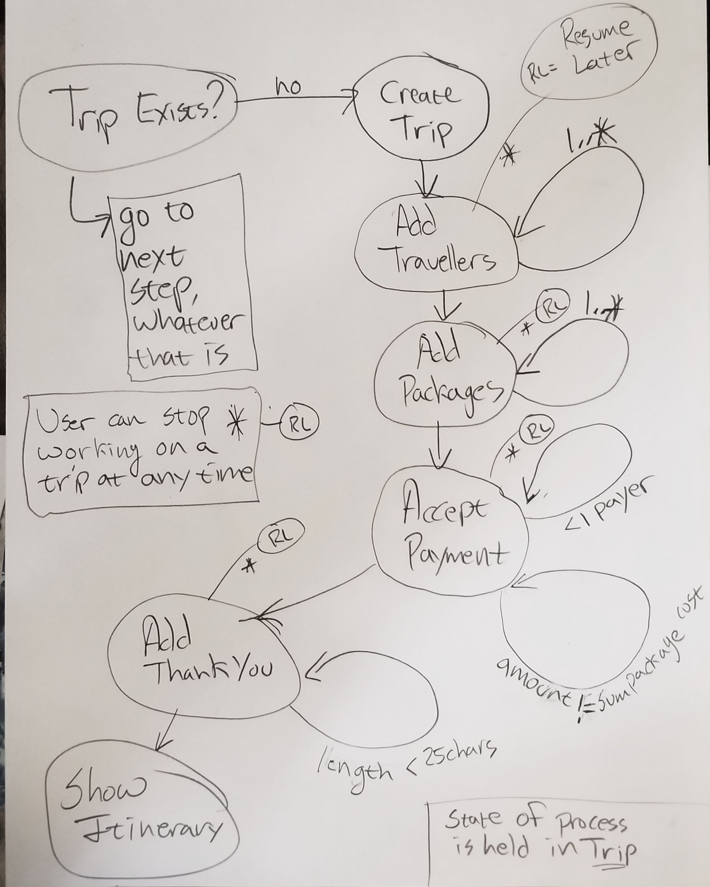

Payer != 1 Person

# Tentative Project, Homework, & Exam Schedule (as of 10/7, subject to change)

* ~~Tuesday, October 2~~~~nd~~*~~Project introduced~~*
* ~~Thursday, October 4~~~~th~~*~~Iteration 1 review  
  JSON & XML serialization lecture  
  Inform instructor whether team of 1 or team of 2~~*
* **Tuesday, October 23rd**   
  ***Iteration 1 due*** *Iteration 2 review*
* Tuesday, November 6th   
  *Iteration 2 due  
  Iteration 3 review*
* Tuesday, November 13th  
  *Iteration 4 review  
  Draw number for presentation date*
* Thursday, November 15th  
  *Exam 2*
* November 17th – November 25th   
  *Fall Break*
* Tuesday, November 27th   
  *Iterations 3 and 4 due*
* Tuesday, November 27th and Thursday, November 29th   
  *Presentations (order randomly picked)*
* Final Exam

*There will also be two homework items to practice design patterns:*

* *Homework 3 - between Iteration 1 and 2*
* *Homework 4 - between Iteration 2 and 3*